Terms and Conditions
Morwell Innovation Centre (Facility Hire)

Dear Guest,

Thank you for your booking. The Morwell Innovation Centre does not provide catering, but we are more than happy to recommend local caterers for your booking.
The operating business hours for the Morwell Innovation Centre are from 9:00am to 5:00pm Monday to Friday. If you would like to hold a meeting or event outside of business hours, please contact us directly through mic@federation.edu.au
The kitchens in the Morwell Innovation Centre are shared spaces used by tenants and guests to the centre. Any catering or equipment that you bring should be clearly labelled. Tea and coffee are available free of charge and are inclusive of your booking.
Plates, glasses, cups, cutlery, and water jugs are available that you are welcome to use. The Morwell Innovation Centre has instant hot and cold water available via the tap in the kitchen.
AV
Each room is equipped with AV equipment.
An instruction guide is in each room on how to use the equipment.
Please ensure you have a HDMI and USB port in your computer.
If you have a device that does not support either of the above, please bring an adapter with you.
The Morwell Innovation Centre does not stock adapters.
Apple Mac computers can be temperamental with the AV system, please keep this in mind when choosing your equipment for your meeting.
The two larger rooms in the centre are fitted with built-in room microphones.
We strongly recommend that you arrive at least 30 minutes prior to your meeting or event to ensure you are familiar with the technology.
Free Wi Fi Available
Wi Fi is available via Fed Uni Guest Wi Fi. You need to connect through your internet access icon and once you hit connect you will then need to go into your internet browser to Accept the Terms and Conditions. You should then be connected. Some organisations have firewalls which may not allow you to connect. If you are unsure, we recommend you check with your system administrator.

Car Parking
Car Parking is very limited at the Morwell Innovation Centre.
There is short term 4hour parking adjacent to the centre however we recommend parking
in the all day car park at the eastern end of the precinct (see campus map)

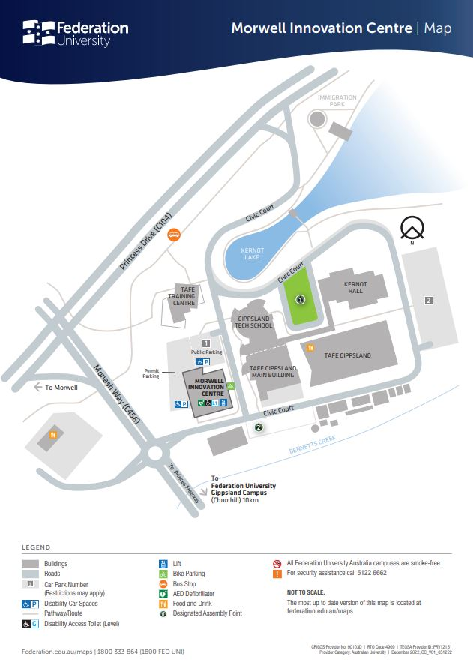

If you have any further queries, please email mic@federation.edu.au.

